SIMATS ENGINEERING (SAVEETHA SCHOOL OF ENGINEERING)
Department of Computer Science and Engineering

ASSESSMENT TOOL 3– Hackathon

Course Code: | DSA0404 | Course Title: | FUNDAMENTALS OF DATA  SCIENCE
CO Assessed: | C05-Hackathon | Assessment: | Assessment Tool 3–Hackathon
Weightage: | 40% of CIA | Total Marks: | 100
CO5 Statement: | To understand the concept of supervised and unsupervised methods in machine learning
Student Name: | Ramya Y | Reg. No.: | 192424397
Section / Batch: | B.Tech AI & DS ,2024 | Date: | 31-08-2026

Code of Conduct
I Ramya Y (192424397) certify that this submission is my original work and that I have adhered to the guidelines specified for this assessment. I understand that any violation of academic integrity rules will result in disciplinary action.
Signature of the Student: Ramya Y

Criteria | Weight age | Level 4 – Exemplary | Level 3 – Proficient | Level 2 – Developing | Level 1 – Beginning | Marks
Understanding of Case | 25 | Thorough  understanding; clearly identifies all key issues | Good understanding with most issues identified | Basic understanding; some issues missed | Poor understanding; problem not identified correctly
Application of Concepts | 25 | Effectively applies relevant concepts to analyze the case deeply | Applies appropriate concepts with minor gaps | Limited application of concepts | Fails to apply relevant concepts
Analysis | 20 | In-depth analysis with strong reasoning and insights | Good analysis with logical reasoning | Basic analysis with limited depth | Weak or no analysis; lacks reasoning
Solution Design | 20 | Innovative, feasible solutions with strong justification | Logical solutions with  adequate  justification | Basic solutions with weak justification | Incorrect or no solution provided
Clarity | 10 | Clear, well-structured, and easy to understand | Organized and understandable presentation | Limited clarity and structure | Poor clarity; difficult to understand

Problem Statement:
Sales Forecasting for Retail. Predict monthly/quarterly sales for a retail store using historical sales, promotions, and seasonality as features via multiple linear regression.
Source Code:
import streamlit as st
import pandas as pd
import numpy as np
import plotly.express as px

from sklearn.linear_model import LinearRegression
from sklearn.metrics import mean_absolute_error, mean_squared_error, r2_score

# =========================================================
# PAGE SETTINGS
# =========================================================

st.set_page_config(
page_title="Retail Sales Forecasting",
page_icon="📈",
layout="wide"
)

# =========================================================
# TITLE
# =========================================================

st.title("📈 Retail Sales Forecasting System")

st.write(
"Predict monthly retail sales using historical sales, "
"promotions and seasonality with Multiple Linear Regression."
)

# =========================================================
# LOAD DATA
# =========================================================

@st.cache_data
def load_data():

data = pd.read_csv("sales_data.csv")

data["Date"] = pd.to_datetime(data["Date"])

data = data.sort_values("Date")

return data

try:

df = load_data()

except FileNotFoundError:

st.error(
"sales_data.csv was not found. "
"Please place sales_data.csv in the same folder as app.py."
)

st.stop()

# =========================================================
# DATA PREPROCESSING
# =========================================================

df = df.drop_duplicates()

df = df.dropna(
subset=["Date", "Sales", "Promotion"]
)

# =========================================================
# FEATURE ENGINEERING
# =========================================================

df["Month"] = df["Date"].dt.month

df["Quarter"] = df["Date"].dt.quarter

df["Year"] = df["Date"].dt.year

# Previous month's sales
df["Previous_Sales"] = df["Sales"].shift(1)

# Three-month moving average
df["Sales_MA_3"] = (
df["Sales"]
.rolling(window=3)
.mean()
)

# Remove rows containing NaN values
df = df.dropna().reset_index(drop=True)

# =========================================================
# SIDEBAR
# =========================================================

st.sidebar.header("🔧 Forecast Settings")

forecast_promotion = st.sidebar.slider(
"Promotion (%)",
min_value=0,
max_value=100,
value=20
)

forecast_month = st.sidebar.selectbox(
"Forecast Month",
list(range(1, 13)),
index=0
)

forecast_quarter = (
(forecast_month - 1) // 3
) + 1

# =========================================================
# FEATURES AND TARGET
# =========================================================

features = [
"Previous_Sales",
"Promotion",
"Month",
"Quarter",
"Sales_MA_3"
]

X = df[features]

y = df["Sales"]

# =========================================================
# TRAIN / TEST SPLIT
# =========================================================

split_index = int(len(df) * 0.8)

X_train = X.iloc[:split_index]

X_test = X.iloc[split_index:]

y_train = y.iloc[:split_index]

y_test = y.iloc[split_index:]

# =========================================================
# TRAIN MODEL
# =========================================================

model = LinearRegression()

model.fit(
X_train,
y_train
)

# =========================================================
# TEST PREDICTION
# =========================================================

y_pred = model.predict(
X_test
)

# =========================================================
# MODEL EVALUATION
# =========================================================

mae = mean_absolute_error(
y_test,
y_pred
)

rmse = np.sqrt(
mean_squared_error(
y_test,
y_pred
)
)

r2 = r2_score(
y_test,
y_pred
)

# =========================================================
# DASHBOARD METRICS
# =========================================================

col1, col2, col3, col4 = st.columns(4)

with col1:

st.metric(
"Average Sales",
f"₹{df['Sales'].mean():,.0f}"
)

with col2:

st.metric(
"MAE",
f"₹{mae:,.0f}"
)

with col3:

st.metric(
"RMSE",
f"₹{rmse:,.0f}"
)

with col4:

st.metric(
"R² Score",
f"{r2:.2f}"
)

# =========================================================
# HISTORICAL SALES TREND
# =========================================================

st.subheader("📊 Historical Sales Trend")

fig1 = px.line(
df,
x="Date",
y="Sales",
title="Monthly Sales"
)

st.plotly_chart(
fig1,
use_container_width=True
)

# =========================================================
# PROMOTION ANALYSIS
# =========================================================

st.subheader("🎯 Promotion vs Sales")

fig2 = px.scatter(
df,
x="Promotion",
y="Sales",
trendline="ols",
title="Impact of Promotion on Sales"
)

st.plotly_chart(
fig2,
use_container_width=True
)

# =========================================================
# MONTHLY SEASONALITY
# =========================================================

st.subheader("📅 Monthly Seasonality")

monthly_sales = (
df.groupby("Month")["Sales"]
.mean()
.reset_index()
)

fig3 = px.bar(
monthly_sales,
x="Month",
y="Sales",
title="Average Sales by Month"
)

st.plotly_chart(
fig3,
use_container_width=True
)

# =========================================================
# ACTUAL VS PREDICTED
# =========================================================

st.subheader("🤖 Actual vs Predicted Sales")

comparison = pd.DataFrame({

"Date": df.iloc[split_index:]["Date"].values,

"Actual Sales": y_test.values,

"Predicted Sales": y_pred

})

fig4 = px.line(
comparison,
x="Date",
y=["Actual Sales", "Predicted Sales"],
title="Actual vs Predicted Sales"
)

st.plotly_chart(
fig4,
use_container_width=True
)

# =========================================================
# FUTURE SALES FORECAST
# =========================================================

st.subheader("🔮 Future Sales Forecast")

latest_previous_sales = (
df["Sales"].iloc[-1]
)

latest_moving_average = (
df["Sales_MA_3"].iloc[-1]
)

future_data = pd.DataFrame({

"Previous_Sales": [
latest_previous_sales
],

"Promotion": [
forecast_promotion
],

"Month": [
forecast_month
],

"Quarter": [
forecast_quarter
],

"Sales_MA_3": [
latest_moving_average
]

})

future_prediction = model.predict(
future_data
)[0]

st.success(
f"🔮 Predicted Sales: ₹{future_prediction:,.2f}"
)

# =========================================================
# WHAT-IF PROMOTION ANALYSIS
# =========================================================

st.subheader("💡 What-If Promotion Analysis")

promotion_values = [
0,
10,
20,
30,
40,
50
]

what_if_data = pd.DataFrame({

"Previous_Sales":
[latest_previous_sales] *
len(promotion_values),

"Promotion":
promotion_values,

"Month":
[forecast_month] *
len(promotion_values),

"Quarter":
[forecast_quarter] *
len(promotion_values),

"Sales_MA_3":
[latest_moving_average] *
len(promotion_values)

})

what_if_predictions = model.predict(
what_if_data
)

what_if_result = pd.DataFrame({

"Promotion (%)":
promotion_values,

"Predicted Sales":
what_if_predictions

})

fig5 = px.bar(
what_if_result,
x="Promotion (%)",
y="Predicted Sales",
title="Predicted Sales for Different Promotion Levels"
)

st.plotly_chart(
fig5,
use_container_width=True
)

# =========================================================
# BUSINESS RECOMMENDATION
# =========================================================

st.subheader("💡 Business Recommendation")

best_index = (
what_if_result["Predicted Sales"]
.idxmax()
)

best_promotion = (
what_if_result.loc[
best_index,
"Promotion (%)"
]
)

best_sales = (
what_if_result.loc[
best_index,
"Predicted Sales"
]
)

st.info(
f"Based on the model, a "
f"{best_promotion}% promotion gives the highest "
f"predicted sales of ₹{best_sales:,.2f}."
)

# =========================================================
# DATASET
# =========================================================

with st.expander("📋 View Dataset"):

st.dataframe(
df,
use_container_width=True
)

# =========================================================
# MODEL INFORMATION
# =========================================================

with st.expander("ℹ️ About the Model"):

st.write(
"""
Algorithm: Multiple Linear Regression

Target Variable:
Sales

Features:
• Previous Sales
• Promotion
• Month
• Quarter
• Three-Month Moving Average

Evaluation Metrics:
• MAE
• RMSE
• R² Score

The data is split chronologically so that
historical data is used for training and
later data is used for testing.
"""
)

Output:
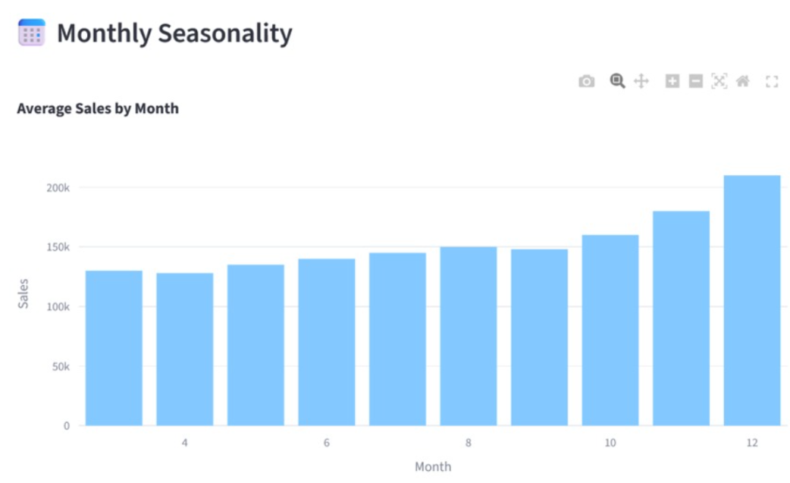

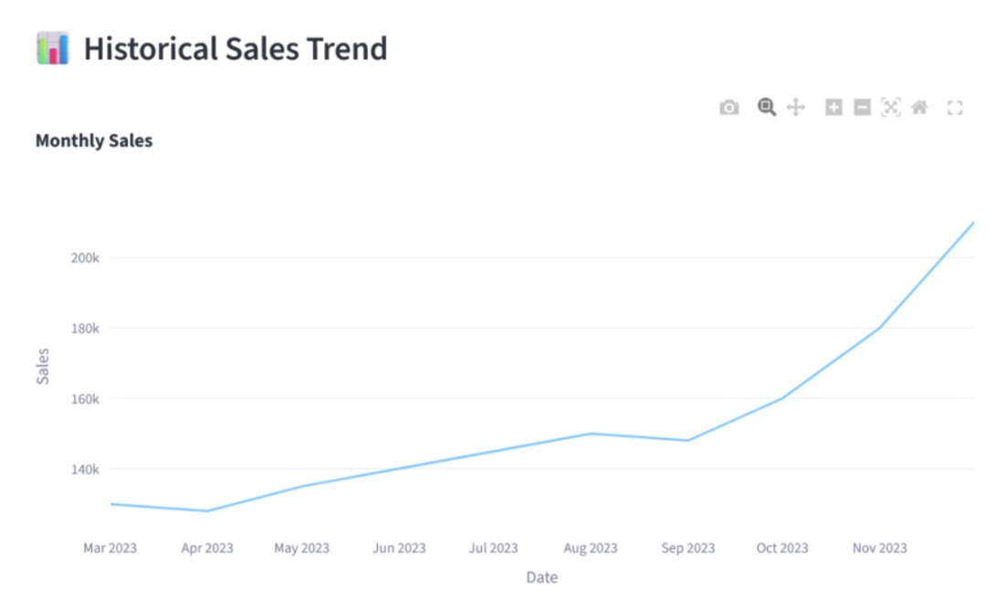
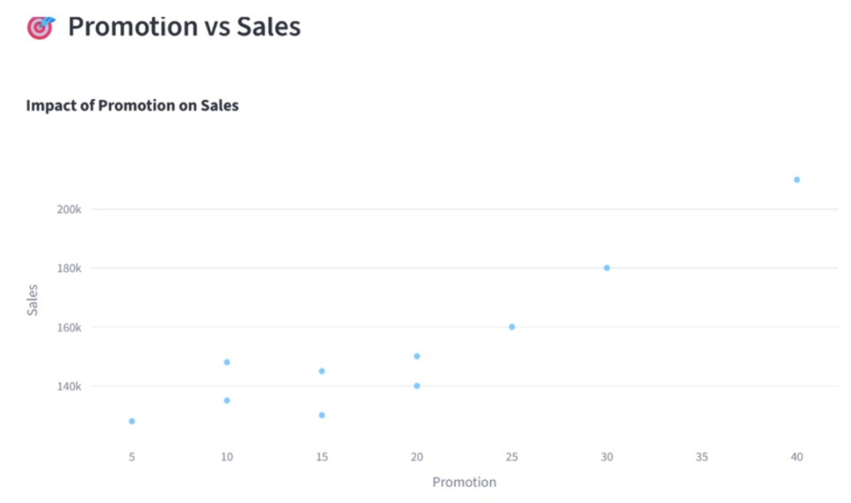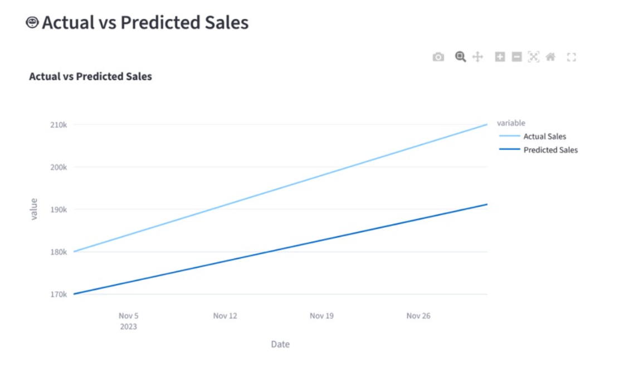
Geo Tag Photo:


